MULTI-SIGNAL WEARABLE DEVICE PLATFORM
Architecture Design Document
Version 1.0 · October 2026 · CONFIDENTIAL
Document Owner | Enterprise Architecture — Dev Experience
Status | Draft
Classification | Internal — Confidential
Last Updated | October 2026

Table of Contents
- 1. Executive Summary
- 2. Scope
- 3. Business Objectives
- 4. Capability Definitions
- 5. Reference Architecture
- 6. Solution Approach
- 7. Integration Details
- 8. Domain-Driven Design
- 9. Context Map
- 10. Data Flow
- 11. Technology Stack & Options
- 12. Implementation Phases & Delivery Plan
- 13. Glossary & Key Terms
- 14. Open Questions & Decisions

1. Executive Summary
This document describes the architecture of the Multi-Signal Wearable Device Platform — a clinical-grade IoT and AI platform that continuously monitors six physiological signals from a wearable medical device and delivers actionable clinical insights to patients, clinicians, care teams, researchers, and hospital administrators.
The platform is designed around three principles: no patient profile stored on the platform, EMR-vendor-agnostic integration via a Port & Adapter pattern, and a generational capability roadmap that grows from threshold alerting (Gen 1) through predictive composite AI (Gen 3).
The architecture follows Domain-Driven Design (DDD) with event-driven bounded contexts, FHIR R4 interoperability, SMART on FHIR authorization, and a novel Device Identity & Binding pattern that enables device-initiated signal flows without storing patient identifiers.

2. Scope
This architecture document covers:
- Six-signal wearable device: Bio-impedance, Pressure, pH, SpO₂, Hydrogen Peroxide, Temperature
- Eleven bounded contexts across Core, Supporting, and Generic classifications
- EMR integration with Epic, Oracle Cerner, and any FHIR R4-compliant system via Port & Adapter
- Six personas: Patient, Clinician, Care Team, Researcher, Hospital Administrator, Corporate Administrator
- Three generational releases: Gen 1 → Gen 2 → Gen 3
- Privacy constraints: no patient profile on platform; SMART on FHIR authorization; opaque device-patient token

Out of scope:
- Device hardware firmware and manufacturing
- EMR system configuration or administration
- Clinical protocol design or FDA clearance strategy
- Enterprise IT infrastructure provisioning

3. Business Objectives
Objective | Description | Success Metric
Continuous Remote Monitoring | Enable continuous multi-signal monitoring outside the hospital setting | ≥99.5% signal uptime; P99 latency <5s device-to-insight
Clinical Decision Support | Deliver AI-driven risk scores and LLM clinical summaries inside the clinician's existing EMR workflow | Risk score available within 30s of observation; SOAP draft accuracy validated by clinical pilot
EMR Interoperability | Integrate with any FHIR R4-compliant EMR without bespoke per-hospital engineering | Zero platform code changes to onboard a new FHIR R4 EMR
Patient Privacy | Store no identifiable patient data on the platform | Zero PII/PHI written to platform databases; confirmed by security audit
Care Escalation | Surface high-risk patients to care teams before acute deterioration | Escalation latency <60s from CDS alert to care team notification
Research Enablement | Provide researchers with a de-identified cohort explorer and signal export | First research cohort query available within Gen 2 release
Operational Visibility | Give Corporate Administrators real-time visibility into device fleet health and pipeline SLAs | SLA breach alert within 2 minutes of threshold crossing

4. Capability Definitions

4.1 Signals
Signal | Unit | Clinical Relevance
Bio-impedance | Ω (Ohms) | Tissue fluid composition; edema detection; body composition index
Pressure | mmHg | Hemodynamic index; cardiovascular monitoring
pH | pH units | Tissue acidity; oxidative stress proxy
SpO₂ | % | Blood oxygen saturation; hypoxia detection
Hydrogen Peroxide (H₂O₂) | μM (micromolar) | Oxidative stress marker; wound healing and inflammation proxy
Temperature | °C | Fever detection; core body temperature trending

4.2 Personas
Persona | Access Channel | Primary Capabilities
Patient | Mobile app (iOS / Android) | View simplified vitals, SpO₂/pH/temp trends, plain-language alerts
Clinician | EMR app via SMART on FHIR | View risk scores, CDS summaries, SOAP draft notes inside EMR workflow
Care Team | EMR app via SMART on FHIR | Manage escalation queue, panel assignments, deterioration velocity
Researcher | Platform web app | Cohort explorer, de-identified signal export, feature library
Hospital Administrator | Platform web app | Population health dashboards, readmission risk stratification
Corporate Administrator | Platform web app | Device fleet health, pipeline SLA, error codes, data loss events

4.3 Generational Roadmap
Generation | Signals Active | New Capabilities | New Personas
Gen 1 | Bio-impedance + Temperature | Threshold alerting; device connectivity; patient mobile app; Corporate Admin dashboard | Patient, Corporate Administrator
Gen 2 | + pH + SpO₂ | LLM summaries; SOAP draft write-back; SMART on FHIR EMR embedding; research explorer; population health | + Clinician, Care Team, Researcher, Hospital Administrator
Gen 3 | + Hydrogen Peroxide | Full composite risk (all 6 signals); oxidative stress detection; population-scale ML; all personas at full capability | All 6 personas

5. Reference Architecture
The reference architecture organizes the platform into five horizontal layers. Data flows top-to-bottom from the physical device through processing, intelligence, and integration to access endpoints.

5.1 Architecture Layers
Layer | Components | Responsibility
Layer 1 — Device & Edge | Wearable Device, BLE/LTE uplink, Edge Gateway (IoT Greengrass / IoT Edge) | Signal capture, packet transmission, edge pre-processing, packet validation
Layer 2 — Connectivity & Identity | Device Connectivity, Device Identity & Binding | Ingest validated packets; resolve serial number → patient token; device health monitoring
Layer 3 — Processing & Intelligence | Signal Processing, Clinical Decision Support | 6-signal fusion, derived metrics, baseline computation, risk scoring, anomaly detection, LLM summaries
Layer 4 — Domain Services | Care Coordination, Patient Engagement, Research Analytics, Population Health, Platform Observability, Audit & Compliance | Domain-specific workflows, dashboards, escalation queues, compliance event log
Layer 5 — Integration & Access | EMR Integration Gateway (IEMRGateway + Adapters), Platform Web App, Patient Mobile App | FHIR write-back, SMART on FHIR, clinician EMR embedding, researcher/admin web UI, patient mobile

5.2 Cross-Cutting Concerns
Concern | Approach
Event Bus | Apache Kafka — all inter-context communication flows via domain events; no direct service-to-service calls across bounded context boundaries
Authentication & Authorization | SMART on FHIR (EMR users); OAuth2 + RBAC (platform web app); device certificates (device layer)
Observability | Prometheus + Grafana (metrics); structured JSON logging; PagerDuty (alerting); OpenLineage (data lineage)
Secret Management | AWS Secrets Manager / Azure Key Vault — HMAC keys, API tokens, database credentials
Data Privacy | PatientReference session-only; DevicePatientToken one-way hash; no PII/PHI in platform databases; WORM audit log
Scalability | Kafka-backed async processing; stateless microservices; Redis for hot path (baseline, binding lookup); InfluxDB for time-series scale
Compliance | HIPAA BAA with cloud providers; immutable audit log; OpenLineage lineage; consent tracking; SaMD classification TBD

6. Solution Approach

6.1 Architecture Principles
No patient profile on platform: PatientReference is session-only (FHIR Patient ID from SMART on FHIR). DevicePatientToken is a one-way HMAC hash. No name, DOB, MRN, or clinical history stored.
EMR-vendor-agnostic: Port & Adapter pattern (IEMRGateway). Adding a new EMR = one new adapter. No platform core changes.
Event-driven: Bounded contexts communicate via Kafka domain events. No synchronous cross-context calls.
AI-augmented, not AI-dependent: LLM outputs are presented as suggestions. Clinicians review and accept before write-back to EMR.
Generational delivery: Three generations tied to signal activation. Reduces clinical validation scope per release.
Hyperscaler-agnostic: AWS and Azure equivalents specified for every component. No proprietary lock-in beyond commodity primitives.

6.2 Bounded Context Overview
Bounded Context | Type | Responsibility
Signal Processing | Core | 6-signal fusion, derived metrics, baseline, quality scoring
Clinical Decision Support | Core | Risk scoring (0–100), anomaly detection, LLM summaries, SOAP drafts
Patient Engagement | Supporting | Simplified vitals, trends, plain-language alerts for patient mobile
Care Coordination | Supporting | Escalation queue, panel assignment, deterioration velocity
Research Analytics | Supporting | De-identified cohort explorer, signal export, feature library
Population Health | Supporting | Risk stratification dashboards, readmission scoring
Platform Observability | Supporting | Device fleet health, pipeline SLA, error codes, data loss
Device Identity & Binding | Generic | Serial number → DevicePatientToken mapping
Audit & Compliance | Generic | Immutable event log, consent, OpenLineage lineage
Device Connectivity | Generic | BLE/LTE uplink, edge pre-processing, packet validation
EMR Integration Gateway | Generic | IEMRGateway port + EpicAdapter, CernerAdapter, GenericFHIRAdapter

7. Integration Details

7.1 EMR Integration — Port & Adapter
The IEMRGateway port is a Python abstract base class. Each adapter implements it independently and handles vendor-specific FHIR extensions, auth scopes, and marketplace registration without exposing those details to the platform core.
class IEMRGateway:
def get_patient_reference(self, launch_token: str) -> PatientReference: ...
def resolve_patient_from_token(self, token: DevicePatientToken, tenant_id: str) -> PatientReference: ...
def write_observation(self, ref: PatientReference, obs: SignalObservation) -> str: ...
def write_risk_score(self, ref: PatientReference, assessment: RiskAssessment) -> str: ...
def write_soap_draft(self, ref: PatientReference, assessment: RiskAssessment) -> str: ...
def write_escalation_alert(self, ref: PatientReference, esc: Escalation) -> str: ...
Adapter | EMR | Registration | Vendor-Specific Handling
EpicAdapter | Epic Aura | Epic App Orchard | Epic FHIR extensions; In-Basket alerts; Epic EPI patient ID format
CernerAdapter | Oracle Cerner | Cerner App Gallery | Cerner FHIR extensions; Message Center; Cerner MPI patient ID format
GenericFHIRAdapter | Any FHIR R4 EMR | Per-vendor | Standard FHIR R4 only — Athena, Meditech, Allscripts, others

7.2 Device-to-Patient Identity Binding
Step | Actor | Action
1 | Clinician | Opens platform via SMART on FHIR launch — PatientReference received in launch token
2 | Platform | Creates DevicePatientBinding: serial → HMAC-SHA256(TenantID + FHIR PatientID)
3 | Device | Transmits signal packet with serial number only — no patient data on device
4 | Device Connectivity | Looks up DevicePatientBinding by serial → retrieves DevicePatientToken
5 | IEMRGateway | Calls resolve_patient_from_token(token, tenant_id) → adapter decodes → FHIR Patient/{id}
6 | Platform | Uses PatientReference for pipeline — never persists it to database

7.3 FHIR Write-Back Resources
Platform Output | FHIR Resource | Gen Available
Signal observation | Observation (LOINC-coded per signal type) | Gen 1
Risk score | Observation (value + tier) | Gen 2
LLM clinical summary | DocumentReference (narrative) | Gen 2
SOAP draft note | DocumentReference (SOAP structured) | Gen 2
Escalation alert | Communication (to care team) | Gen 2

7.4 Generic vs. Vendor-Specific
Concern | Generic (all adapters) | Vendor-Specific (each adapter handles)
Auth | SMART on FHIR OAuth2 launch | App marketplace registration (App Orchard, Cerner Gallery)
Patient identity | FHIR Patient resource ID | Custom MRN formats; Epic EPI vs Cerner MPI
Signal write-back | FHIR R4 Observation | Custom LOINC mappings per EMR
SOAP draft | FHIR R4 DocumentReference | Epic note type codes
Escalation | FHIR R4 Communication | Epic In-Basket vs Cerner Message Center

8. Domain-Driven Design

8.1 Aggregates

SignalObservation — Signal Processing
Field | Type | Notes
id | ObservationId | Unique observation identifier
patientId | PatientId | Opaque reference — FHIR Patient ID from session
capturedAt | Timestamp | Must not be in the future
signals | RawSignals | All 6 fields required; missing field → observation rejected
derived | DerivedMetrics | Populated only when quality ≥ 0.6
quality | float 0–1 | Signal integrity: noise, electrode contact, motion artifact

RiskAssessment — Clinical Decision Support
Field | Type | Notes
id | AssessmentId
patientId | PatientId
score | RiskScore 0–100 | Tier: Low / Moderate / High / Critical
factors | List[RiskFactor] | ≥1 required if tier Moderate or higher
summary | ClinicalSummary | LLM narrative citing signal evidence
assessedAt | Timestamp

DevicePatientBinding — Device Identity & Binding
Field | Type | Notes
id | BindingId
serialNumber | SerialNumber | Immutable hardware identity
devicePatientToken | DevicePatientToken | HMAC-SHA256(tenantId + FHIR PatientID) — write-once
tenantId | TenantId | Required to decode token at adapter
emrVendor | Enum | EpicAdapter | CernerAdapter | GenericFHIRAdapter
boundBy | PractitionerId | Clinician who created the binding
status | Enum | Active | Expired | Revoked

Invariants: one Active binding per serial number; token is write-once; rebinding requires explicit revocation.

8.2 Domain Events Catalog
Event | Raised By | Consumed By
SignalObservationRecorded | Signal Processing | CDS, Patient Engagement, Research Analytics
BaselineUpdated | Signal Processing | CDS
HypoxiaFlagRaised | Signal Processing | CDS, Care Coordination
OxidativeStressSpikeDetected | Signal Processing | CDS
FeverFlagRaised | Signal Processing | CDS, Patient Engagement
RiskAssessmentCompleted | CDS | Care Coordination, Patient Engagement, Population Health
EscalationTriggered | Care Coordination | Patient Engagement
EscalationResolved | Care Coordination | Population Health
PatientSessionEstablished | EMR Integration Gateway | Signal Processing, CDS, Patient Engagement
PatientSessionExpired | EMR Integration Gateway | All contexts
RiskScoreWrittenToEMR | EMR Integration Gateway | Audit & Compliance
SOAPDraftWrittenToEMR | EMR Integration Gateway | Audit & Compliance
DevicePatientBindingCreated | Device Identity & Binding | EMR Integration Gateway, Audit & Compliance
DevicePatientBindingRevoked | Device Identity & Binding | EMR Integration Gateway, Audit & Compliance
DevicePatientBindingExpired | Device Identity & Binding | EMR Integration Gateway, Platform Observability
DeviceOfflineDetected | Device Connectivity | Platform Observability
PipelineLatencyBreached | Signal Processing | Platform Observability
SLABreachTriggered | Platform Observability | Corporate Administrator

9. Context Map
The context map describes how bounded contexts relate to each other and to external systems using DDD relationship patterns.
Upstream | Downstream | Pattern | What Flows
Device Connectivity | Signal Processing | Published Language | Validated signal packets
Device Connectivity | Platform Observability | Published Language | Device health events
Device Connectivity | Device Identity & Binding | Customer-Supplier | SerialNumber from packet
Device Identity & Binding | EMR Integration Gateway | Customer-Supplier | DevicePatientToken
Signal Processing | Clinical Decision Support | Customer-Supplier | Derived metrics + baselines
Signal Processing | Patient Engagement | Customer-Supplier | Baseline + trend data
Signal Processing | Research Analytics | Open Host Service | Time-series API
Signal Processing | Population Health | Open Host Service | Aggregated signals
Signal Processing | Platform Observability | Customer-Supplier | Pipeline latency metrics
CDS | Care Coordination | Customer-Supplier | Risk scores + alerts
CDS | Patient Engagement | Customer-Supplier | Risk score + summary
Care Coordination | Population Health | Customer-Supplier | Panel + tasks
EMR Integration Gateway | Signal Processing / CDS / CC | ACL (Conformist) | PatientReference
External EMR | EMR Integration Gateway | SMART on FHIR | Launch context + PatientReference
All contexts | Audit & Compliance | ACL → event stream | Domain events (immutable log)

10. Data Flow

10.1 Signal Ingestion — Device to Insight
Step 1 — Device Transmission: Wearable captures all active signals and transmits via BLE (local) or LTE (remote): SerialNumber + raw signal readings.
Step 2 — Device Connectivity: Edge validates packet, rejects malformed, applies pre-processing, publishes validated event to Kafka.
Step 3 — Identity Resolution: Lookup DevicePatientBinding by SerialNumber → DevicePatientToken. IEMRGateway.resolve_patient_from_token() returns PatientReference for pipeline.
Step 4 — Signal Processing: Validates quality (≥0.6), computes DerivedMetrics (oxidative stress, hypoxia flag, tissue index, hemodynamic index, fever flag), updates patient baseline.
Step 5 — Clinical Decision Support: On SignalObservationRecorded: evaluates risk factors, computes RiskScore (0–100), invokes Claude API for ClinicalSummary and SOAP draft.
Step 6 — Care Coordination: On RiskAssessmentCompleted tier ≥ High: creates Escalation, pushes to care team queue inside EMR.
Step 7 — EMR Write-Back: EMR Gateway writes RiskScore (FHIR Observation), summary (FHIR DocumentReference), SOAP draft (FHIR DocumentReference) to clinician EMR.
Step 8 — Audit: Every domain event mirrored to immutable WORM log with OpenLineage lineage tracking.

10.2 Clinician Session Flow
- 1. Clinician launches platform from Epic/Cerner → SMART on FHIR launch token received
- 2. Correct adapter resolves PatientReference from launch token
- 3. Clinician assigns device serial number to patient → DevicePatientBinding created
- 4. Platform displays risk scores, signal trends, CDS summary inside EMR app (embedded)
- 5. Clinician accepts SOAP draft → write_soap_draft() pushes DocumentReference to EMR chart
- 6. Session expires → PatientSessionExpired event; PatientReference cleared from memory

10.3 Patient Data Boundary
The following is NEVER written to any platform database:
- Patient name, date of birth, address, or any demographic
- Medical Record Number (MRN) in any form
- Insurance or billing information
- Existing diagnoses, medication list, or clinical history
- Raw FHIR Patient ID (only the one-way HMAC token is stored)

11. Technology Stack & Options
The table below presents the recommended technology choice for each component alongside evaluated alternatives, so delivery teams can make informed selection decisions based on existing skills and infrastructure.

11.1 Core Platform Stack
Layer | Component | Recommended | AWS Alternative | Azure Alternative | OSS / Vendor-Neutral
Device Edge | Edge gateway | AWS IoT Greengrass | — | Azure IoT Edge | K3s + custom agent
Device Edge | Device registry | AWS IoT Core | — | Azure IoT Hub | Eclipse Mosquitto + PostgreSQL
Event Bus | Message streaming | Apache Kafka (MSK) | Amazon Kinesis | Azure Event Hubs | Apache Kafka (self-managed)
Signal Processing | Time-series store | InfluxDB | Amazon Timestream | Azure Data Explorer | TimescaleDB (PostgreSQL ext)
Signal Processing | Baseline engine | Redis | ElastiCache | Azure Cache for Redis | Redis OSS
Signal Processing | Compute | Python microservices | AWS Lambda (burst) | Azure Functions (burst) | Docker + Kubernetes
CDS — ML | Model training + serving | MLflow + SageMaker | SageMaker Autopilot | Azure ML | MLflow + Seldon Core (K8s)
CDS — LLM | Clinical summaries | Claude API (Sonnet/Haiku) | Amazon Bedrock (Claude) | Azure AI (Claude) | Ollama (self-hosted, non-clinical use)
CDS — Anomaly | Anomaly detection | Isolation Forest | SageMaker built-in | Azure ML Anomaly Detector | PyOD library
Identity & Binding | Binding store | PostgreSQL | RDS PostgreSQL | Azure DB for PostgreSQL | PostgreSQL (self-managed)
Identity & Binding | Token secrets | AWS Secrets Manager | — | Azure Key Vault | HashiCorp Vault
Care Coordination | API + queue | FastAPI + PostgreSQL | — | — | FastAPI + any RDBMS
Care Coordination | Real-time push | WebSocket | AWS API Gateway WebSocket | Azure Web PubSub | Socket.io
Research Analytics | Cohort query | Databricks SQL | Amazon Athena | Azure Synapse | DuckDB (smaller scale)
Population Health | Dashboards | Power BI + Databricks | QuickSight | Power BI + Synapse | Apache Superset (OSS)
Observability | Metrics + dashboards | Prometheus + Grafana | Amazon CloudWatch | Azure Monitor + Grafana | Grafana + Prometheus (OSS)
Observability | Alerting | PagerDuty | AWS SNS + OpsGenie | Azure Monitor Alerts | Alertmanager (OSS)
Audit | Immutable log | Kafka + S3 WORM | S3 Object Lock | ADLS Gen2 + immutability policy | Apache Iceberg + MinIO
Audit | Data lineage | OpenLineage + Marquez | — | Microsoft Purview | OpenLineage (OSS)
EMR Gateway | SMART on FHIR | smart-on-fhir (Python) | — | — | HAPI FHIR (Java)
Frontend — Web | Platform web app | React + FastAPI | — | — | Next.js + FastAPI
Frontend — Mobile | Patient app | React Native | — | — | Flutter
API Gateway | External API surface | AWS API Gateway | — | Azure API Management | Kong (OSS)
Service Mesh | Inter-service mTLS + observability | Istio | AWS App Mesh | Azure Service Fabric Mesh | Linkerd (lighter weight)

11.2 Technology Selection Criteria
Criterion | Guidance
HIPAA / HITRUST compliance | All data stores and compute must support BAA. Verify with cloud provider before selection.
FHIR R4 certification | EMR-facing components should use certified SMART on FHIR libraries (smart-on-fhir, HAPI FHIR).
Latency requirements | Hot path (device → CDS output) must hit P99 <5s. Choose in-memory stores (Redis) for baseline lookups; avoid cold-start serverless on the critical path.
ML model management | MLflow is the recommended experiment tracker regardless of training platform (SageMaker, Azure ML, or local K8s).
LLM provider lock-in | Claude API is accessed via both AWS Bedrock and Azure AI — use an abstraction layer so the provider can be swapped without changing CDS business logic.
Team skills | FastAPI + Python is the default for new services. Only deviate for a specific capability need (e.g., HAPI FHIR for Java teams).

12. Implementation Phases & Delivery Plan

12.1 Phase Overview
Phase | Duration (est.) | Signals Active | Personas | Key Deliverables
Phase 0 — Foundation | 8 weeks | None (infra only) | None | Cloud infrastructure, Kafka cluster, CI/CD pipelines, security baseline, HIPAA BAA, IEMRGateway port + GenericFHIRAdapter scaffold, Device Identity & Binding service
Phase 1 — Gen 1 MVP | 12 weeks | Bio-impedance + Temperature | Patient, Corporate Admin | Device Connectivity, Signal Processing (2 signals), threshold alerting, Patient Mobile App (basic), Corporate Admin dashboard, DevicePatientBinding flow
Phase 2 — Gen 1 Complete | 8 weeks | Bio-impedance + Temperature | Patient, Corporate Admin | Signal baseline engine, patient trend sparklines, SLA alerting, Platform Observability, Audit & Compliance (WORM log), security pen test
Phase 3 — Gen 2 Alpha | 12 weeks | + pH + SpO₂ | + Clinician, Care Team | CDS risk scoring (4 signals), LLM clinical summary (Claude API), EpicAdapter, SMART on FHIR embedding, Escalation queue, SOAP draft (review-only)
Phase 4 — Gen 2 Complete | 10 weeks | + pH + SpO₂ | + Researcher, Hospital Admin | SOAP draft write-back (clinician-accepted), CernerAdapter, Research Analytics cohort explorer, Population Health dashboards, clinical pilot (selected hospital)
Phase 5 — Gen 3 | 14 weeks | + Hydrogen Peroxide | All 6 personas | Full 6-signal composite risk, oxidative stress detection, population-scale ML, all personas at full capability, FDA SaMD determination

12.2 Phase 0 — Foundation Checklist
- Cloud account provisioning and HIPAA BAA execution (AWS and/or Azure)
- GitHub org setup, branch protection, CI/CD pipelines (GitHub Actions)
- Kafka cluster provisioned; topic naming conventions established
- IEMRGateway abstract interface implemented and unit-tested
- GenericFHIRAdapter scaffold with SMART on FHIR auth working against a sandbox FHIR server
- Device Identity & Binding service: PostgreSQL schema, HMAC token generation, Redis cache
- Secrets management (Secrets Manager / Key Vault) with per-tenant HMAC key rotation policy
- HIPAA-compliant logging policy: no PHI in application logs, structured JSON only
- Security baseline: mTLS between services, RBAC on all APIs, WAF on external endpoints
- OpenLineage + Marquez deployed for data lineage tracking
- Audit log: Kafka → S3/ADLS WORM with immutability policy

12.3 Key Dependencies & Risks
Dependency / Risk | Impact | Mitigation
Epic App Orchard registration | Blocks Gen 2 clinician flow — Epic review takes 8–12 weeks | Submit App Orchard application in Phase 0 in parallel with Gen 1 build
Cerner App Gallery registration | Same as Epic — parallel track needed | Submit in Phase 0; use GenericFHIRAdapter as fallback for pilot
HIPAA BAA with cloud provider | All PHI-adjacent data stores are blocked without BAA | Execute BAA before any Phase 0 infra provisioning
FDA SaMD classification | CDS risk scores may require 510(k) or De Novo if deemed a medical device | Engage regulatory counsel in Phase 3; design for predicate device strategy
LLM clinical accuracy | SOAP draft errors could impact patient safety | Clinical pilot validation in Phase 4; human-in-the-loop acceptance gate before write-back
Device serial number collisions | Two devices with same serial number = incorrect patient binding | Enforce globally unique serial numbers at manufacturing; add uniqueness constraint in DB
SMART on FHIR token expiry during long sessions | PatientReference lost mid-session; signal observations unkeyed | Implement token refresh in all adapters; emit warning event 5 minutes before expiry

12.4 Delivery Principles
- Ship working software every sprint — no big-bang releases
- Clinical pilot in Gen 2 before any production EMR write-back is enabled
- Security and privacy review gates at end of each phase (not just end of project)
- Each new EMR adapter must pass an integration test suite against a vendor sandbox before production
- LLM outputs must have a human acceptance step — no autonomous EMR writes
- Observability and audit logging must be complete before the phase goes live (not a post-launch task)

13. Glossary & Key Terms
Term | Definition
ACL (Anti-Corruption Layer) | Translation layer preventing a downstream context from being corrupted by the upstream model. Used at the EMR integration boundary.
Baseline | Personal rolling 7-day median per signal per patient, used to compute deviation and personalize risk scoring.
Bounded Context | DDD pattern — explicit boundary within which a domain model is defined and consistent. Each context owns its own data and logic.
CDS (Clinical Decision Support) | Platform AI engine — risk scoring, anomaly detection, LLM summaries, SOAP drafts.
Derived Metric | Computed value from one or more raw signals: oxidative stress score, hypoxia flag, tissue composition index, hemodynamic index, fever flag.
DevicePatientBinding | Aggregate linking a device serial number to an opaque EMR patient token. Clinician-created at care initiation.
DevicePatientToken | HMAC-SHA256 hash of (TenantID + FHIR PatientID). Opaque — meaningless without the EMR and tenant secret key.
FHIR R4 | Fast Healthcare Interoperability Resources, Release 4. Current HL7 standard for healthcare data exchange. Mandated by the 21st Century Cures Act.
HMAC | Hash-based Message Authentication Code. Used to generate the DevicePatientToken — one-way, keyed, tamper-evident.
IEMRGateway | Port (abstract Python interface) through which the platform communicates with any EMR.
LOINC | Logical Observation Identifiers Names and Codes. Standard clinical terminology in FHIR Observation resources.
PatientReference | Opaque FHIR Patient ID from the connected EMR. Session-only — never written to platform database.
Port & Adapter | Hexagonal Architecture pattern. Port = abstract interface; adapters = vendor-specific implementations.
Risk Score | 0–100 integer from CDS. Tiers: Low (<30), Moderate (30–59), High (60–79), Critical (≥80).
SaMD | Software as a Medical Device. FDA classification for software that meets the definition of a medical device. Relevant to CDS risk score outputs.
SerialNumber | Immutable hardware identity of a physical wearable device, assigned at manufacturing.
SMART on FHIR | Standard OAuth2 authorization framework on top of FHIR. Enables third-party apps to launch inside an EMR with scoped patient context. Mandated by 21st Century Cures Act.
SOAP Draft | Structured clinical note (Subjective, Objective, Assessment, Plan) pre-populated by LLM from CDS output. Clinician reviews and accepts before EMR write.
SpO₂ | Peripheral oxygen saturation — percentage of hemoglobin bound to oxygen, measured non-invasively.
WORM | Write Once Read Many — storage policy that prevents modification or deletion of records after writing. Used for audit log compliance.

14. Open Questions & Decisions
# | Question | Owner | Status
1 | Binding expiry policy: expire at patient discharge, EMR session close, or fixed time window? | Clinical + Platform Arch | Open
2 | Token revocation propagation SLA: how fast must a revoked token be rejected at the adapter? | Platform Arch | Open
3 | Gen 2 LLM selection: Haiku (speed) vs Sonnet (quality) — define latency/quality threshold | CDS Team | Open
4 | SOAP draft acceptance UX: accept inside EMR or platform before write-back? | Clinical UX | Open
5 | Hyperscaler selection: AWS vs Azure — pending infrastructure decision | IT / Cloud Arch | Open
6 | FDA SaMD classification: 510(k) or De Novo for CDS risk score outputs? | Regulatory | Open
7 | React Native vs Flutter for patient mobile app | Mobile Team | Open
8 | Service mesh: Istio (full featured) vs Linkerd (lighter) — depends on team K8s maturity | Platform Arch | Open
9 | Research Analytics: DuckDB (simple) vs Databricks (scale) — depends on cohort size targets | Data Platform | Open
10 | Device serial number uniqueness enforcement: platform-level constraint or manufacturing process? | Device Engineering | Open

Appendix: Architecture Diagrams
The following diagrams provide visual representations of the platform architecture, capability model, domain design, and data flow. Each diagram is accompanied by a brief explanation of what it shows and how to read it.

Appendix A: Reference Architecture
The reference architecture organizes the platform into five horizontal layers. Data flows top-to-bottom from the physical device through edge processing, signal intelligence, domain services, and EMR integration to access endpoints. All inter-layer communication is event-driven via Apache Kafka. The five layers are: (1) Device & Edge — IoT capture and transmission; (2) Connectivity & Identity — packet ingestion and device-patient token binding; (3) Processing & Intelligence — 6-signal fusion and AI risk scoring via Claude API; (4) Domain Services — care coordination, research analytics, observability, and audit; (5) Integration & Access — EMR gateway with Port & Adapter pattern, platform web app, and patient mobile app.
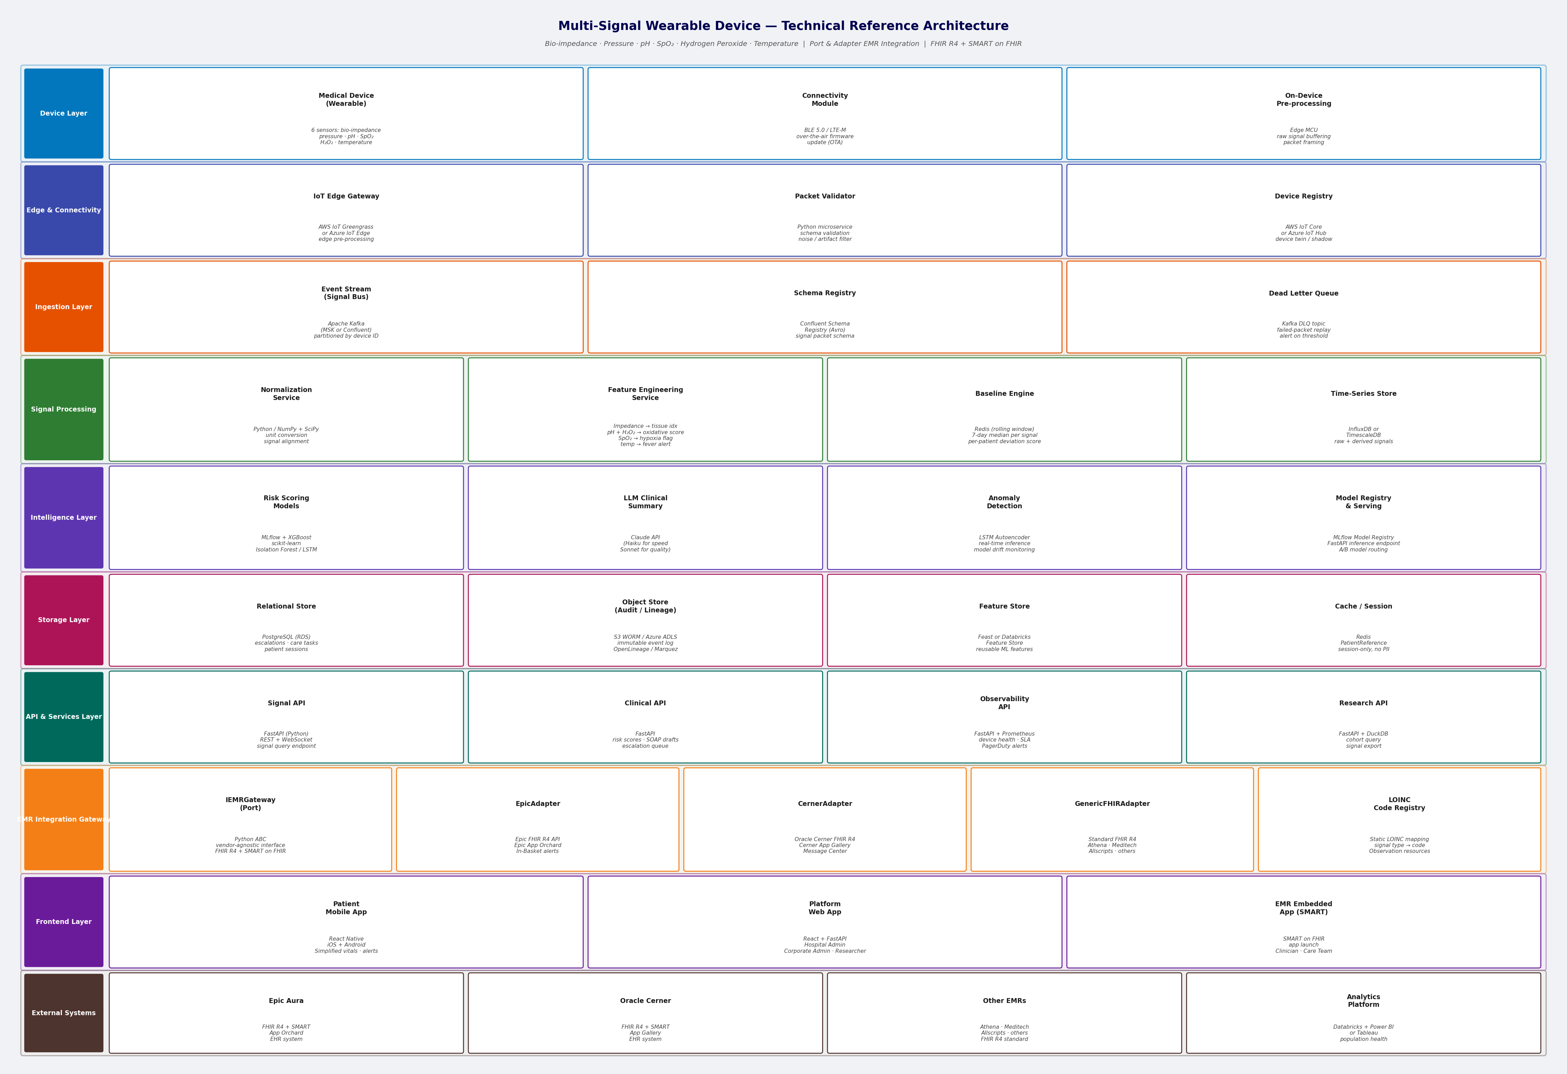
Figure A: Reference Architecture — 5-Layer Platform Model

Appendix B: Persona Capability Model
The capability model maps platform capabilities across six persona swimlanes (Patient, Clinician, Care Team, Researcher, Hospital Administrator, Corporate Administrator) and three capability rows (View, Act, Manage). Each cell represents a specific capability delivered to that persona across the three device generations. The shared data platform footer (Signal Time-Series, Risk Scores, Audit Log) underpins all personas. This model is the primary tool for scoping per-generation feature sets and prioritizing delivery.
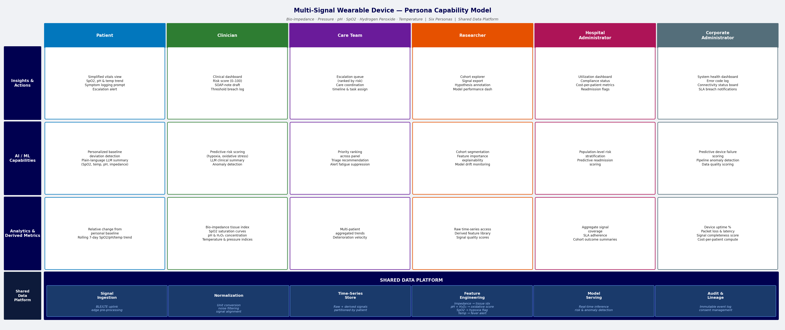
Figure B: Persona Capability Model — 6 Personas × 3 Capability Rows

Appendix C: Generational Capability Roadmap
The generational roadmap defines three sequential capability releases, each tied to the activation of additional sensor signals. Gen 1 (Bio-impedance + Temperature) delivers the foundational monitoring and alerting platform. Gen 2 (+ pH + SpO₂) unlocks AI-driven clinical decision support, SMART on FHIR EMR embedding, and LLM-generated SOAP drafts. Gen 3 (+ Hydrogen Peroxide) completes the full six-signal composite risk model, adds oxidative stress detection, and enables population-scale ML. This phased structure reduces clinical validation scope per release and allows the platform to generate value early while building toward full capability.
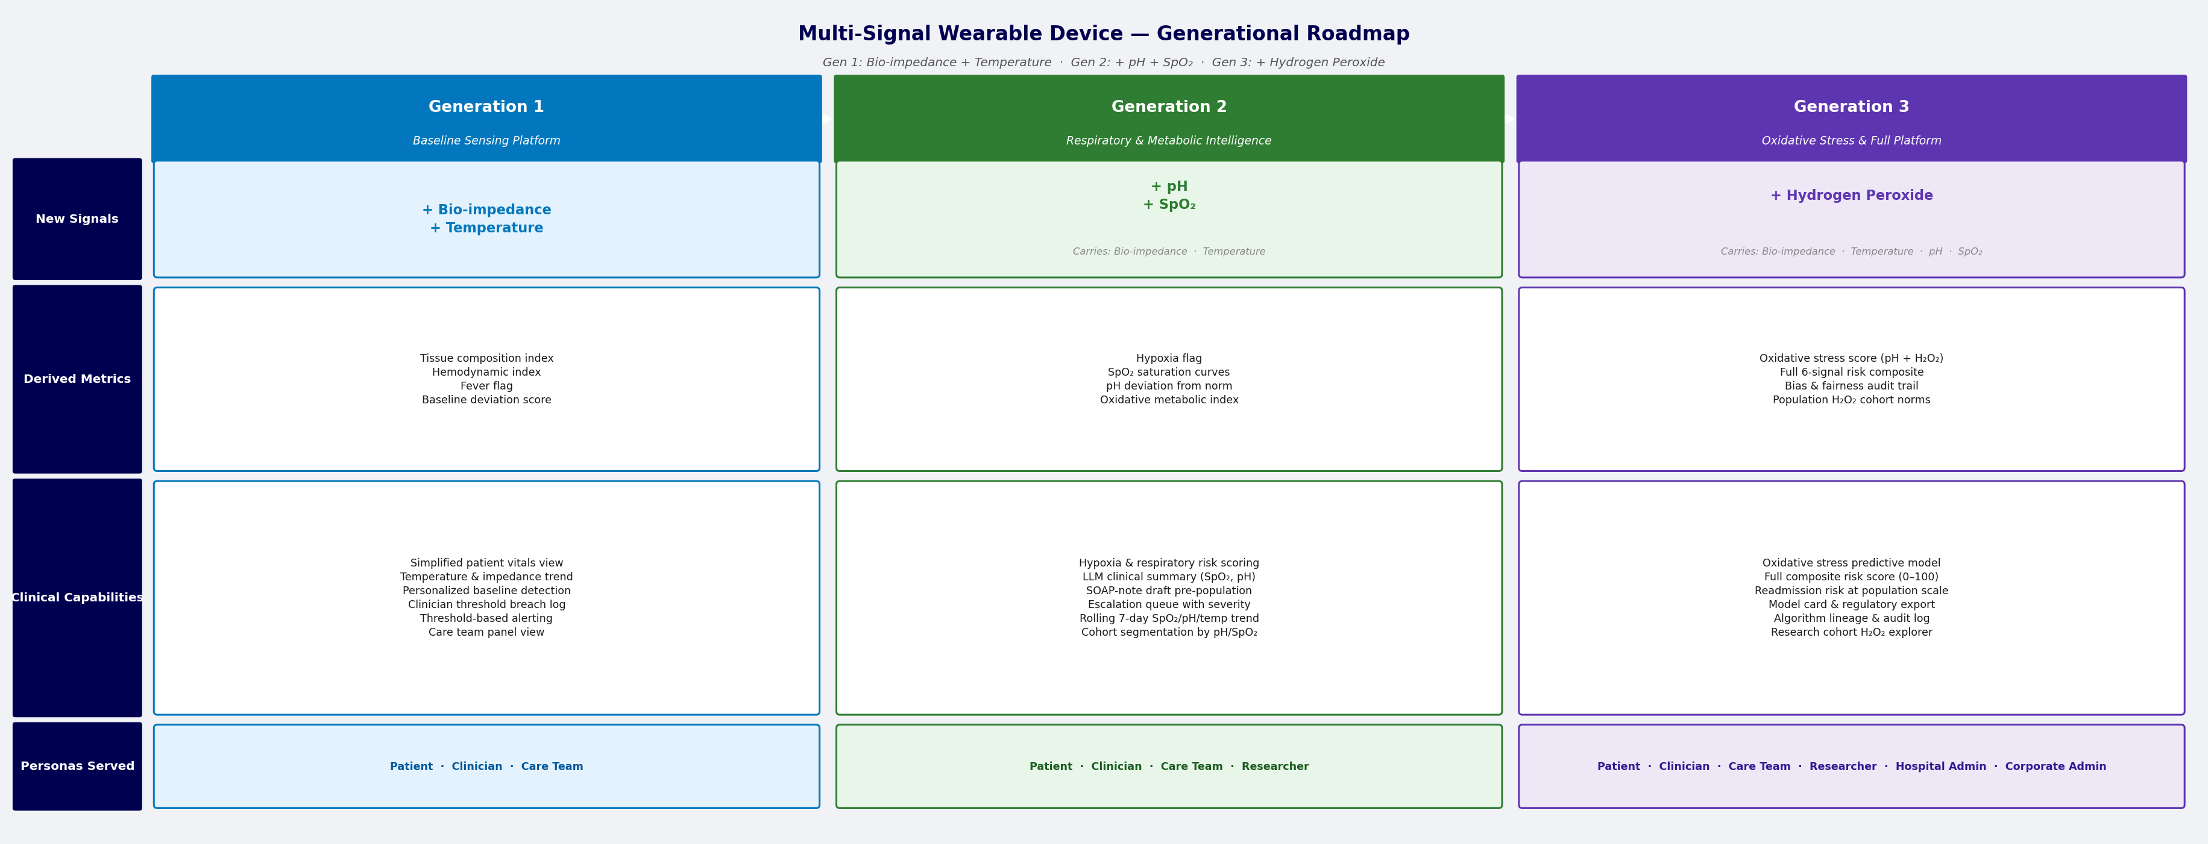
Figure C: Generational Capability Roadmap — 3 Signal Generations

Appendix D: Domain Map — Bounded Contexts
The domain map visualizes all eleven bounded contexts and their inter-relationships using Domain-Driven Design (DDD) patterns. Core contexts (Signal Processing, Clinical Decision Support) are shown in red — these represent the competitive differentiator. Supporting contexts (Patient Engagement, Care Coordination, Research Analytics, Population Health, Platform Observability) are shown in yellow. Generic contexts (Device Connectivity, Device Identity & Binding, Audit & Compliance, EMR Integration Gateway) are shown in green. Arrows are labeled with relationship patterns: Customer-Supplier, Published Language, Open Host Service, Conformist, and ACL (Anti-Corruption Layer).
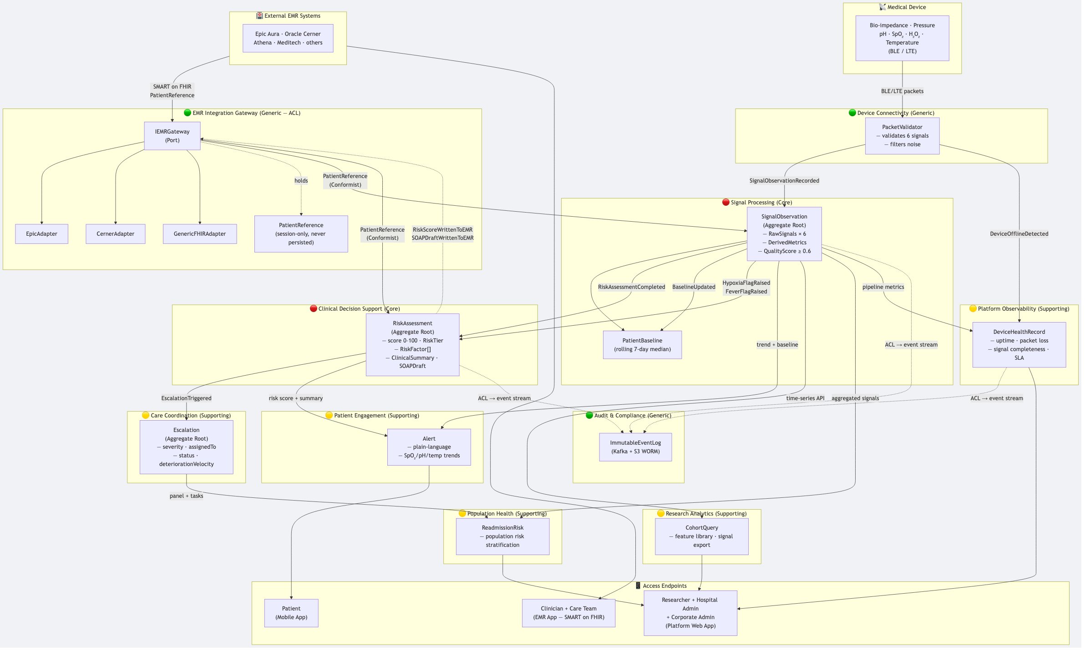
Figure D: DDD Domain Map — 11 Bounded Contexts

Appendix E: Aggregate Class Diagram
The aggregate class diagram shows the internal structure and relationships of the three primary domain aggregates. SignalObservation (Signal Processing context) contains RawSignals (all six sensor values) and DerivedMetrics (computed clinical indicators), gated by a QualityScore threshold of 0.6. RiskAssessment (CDS context) contains a RiskScore with tier classification, a list of contributing RiskFactors with signal evidence, and an LLM-generated ClinicalSummary. DevicePatientBinding (Device Identity & Binding context) maps a SerialNumber to a write-once DevicePatientToken with EMR vendor, binding clinician, and lifecycle status. Each aggregate is the unit of consistency within its bounded context.
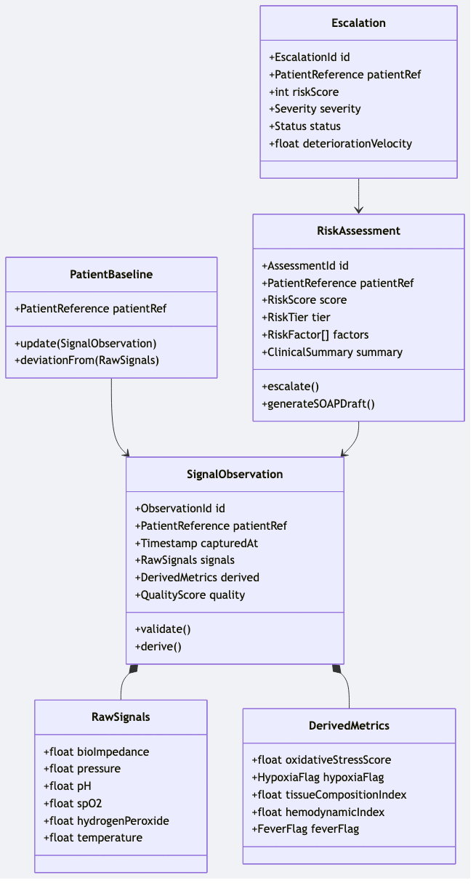
Figure E: Aggregate Class Diagram — 3 Core Aggregates

Appendix F: Domain Events Sequence Diagram
The sequence diagram traces the end-to-end event flow from device signal transmission through to EMR write-back and audit logging. The critical path is: device transmits → Device Connectivity validates and publishes → Signal Processing derives metrics and raises SignalObservationRecorded → CDS evaluates and raises RiskAssessmentCompleted → Care Coordination creates escalation → EMR Integration Gateway writes risk score and SOAP draft back to the clinician’s EMR. All domain events are simultaneously mirrored to the immutable Audit & Compliance log for compliance and lineage tracking.
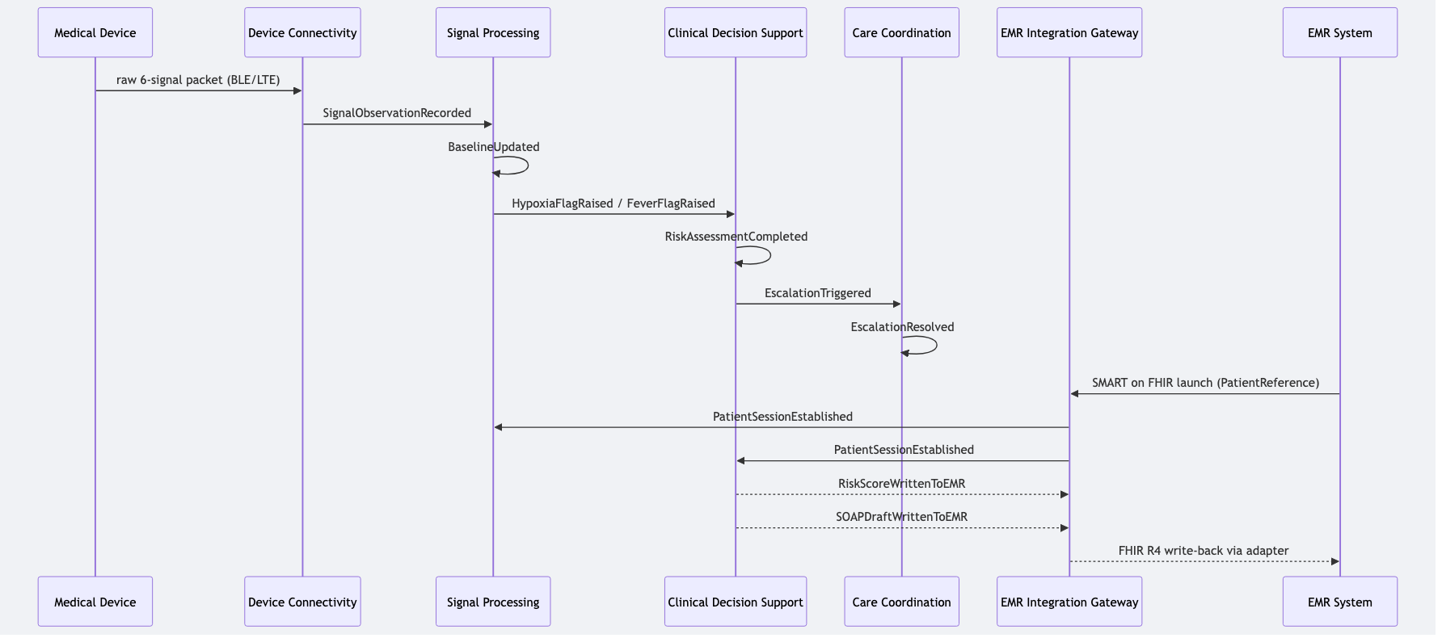
Figure F: Domain Events Sequence — Device to EMR Write-Back

Appendix G: Solution Architecture — Zone View
The solution architecture presents the platform as five deployment zones with explicit data flow arrows and security boundaries. The Device Zone covers the wearable hardware and edge gateway. The Platform Zone hosts the Kafka event bus and all microservices. The Integration Zone contains the IEMRGateway port and its vendor-specific adapters (Epic, Cerner, Generic FHIR). The Access Zone serves the platform web app, patient mobile app, and EMR-embedded clinician UI. The Compliance Zone holds the WORM audit log, OpenLineage lineage store, and consent registry. Zone boundaries enforce security perimeters and data classification policies consistent with HIPAA requirements.
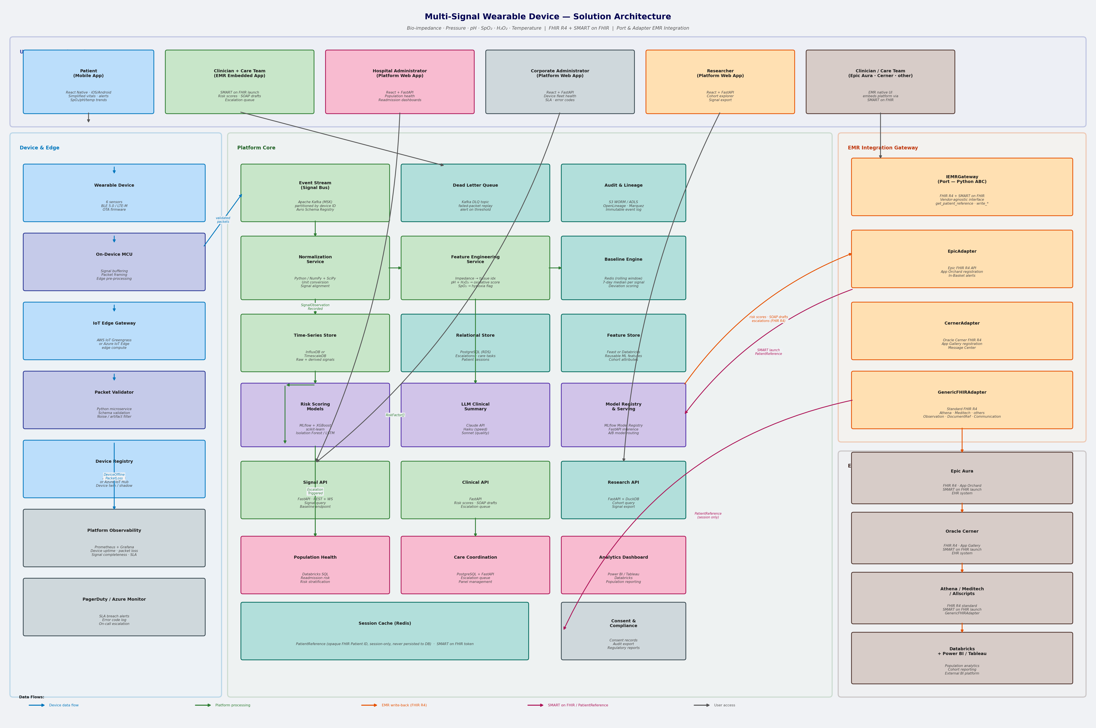
Figure G: Solution Architecture — 5 Deployment Zones

